Mosspits Lane Primary School Curriculum Map 2023 - 2024

Autumn 1   |  | Autumn 2   |  | Spring 1  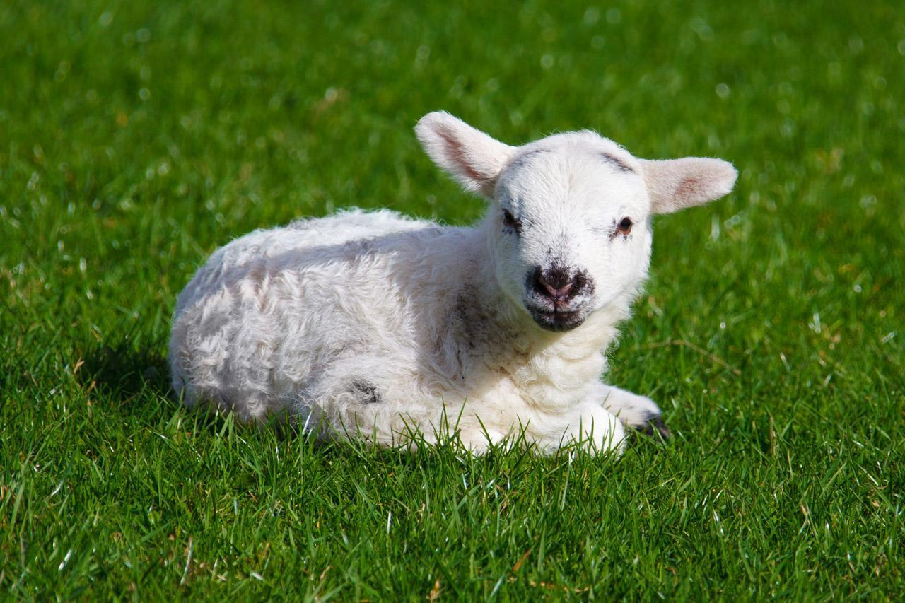 |  | Spring 2  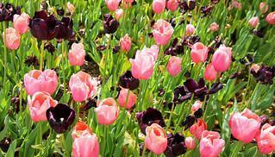 |  | Summer 1   |  | Summer 2  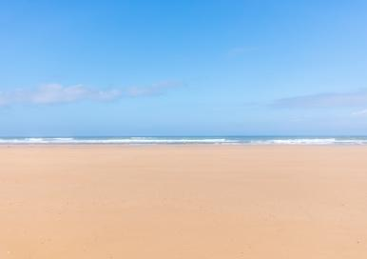
Characteristics of Effective Learning
Playing and exploring: Children investigate and experience things, and ‘have a go’. Children who actively participate in their own play develop a larger store of information and experiences to draw on which positively supports their learning.
Active learning: Children concentrate and keep on trying if they encounter difficulties. They are proud of their own achievements. For children to develop into self-regulating, lifelong learners they are required to take ownership, accept challenges, and learn persistence.
Creating and thinking critically: Children develop their own ideas and make links between these ideas. They think flexibly and rationally, drawing on previous experiences which help them to solve problems and reach conclusions.
Overarching Principles
Unique Child: Every child is a unique child, who is constantly learning and can be resilient, capable, confident and self-assured.
Positive Relationships: Children learn to be strong and independent through positive relationships.
Enabling environments: Children learn and develop well in enabling environments with teaching and support from adults, who respond to their individual interests and needs and help them to build their learning over time. Children benefit from a strong partnership between practitioners and parents.
Learning and Development: Recognising the importance of learning and development and that children develop and learn at different rates.
Curriculum Intent
To support the children to settle into full-time school, feeling happy, safe, and secure.  To provide our children with exciting opportunities to develop independent skills.  To empower children to know how to ‘look, listen and learn’.  To commit to our promise that our children will “Talk, Read and Play… every single day”. |  |  |  | To empower our children to know how to ‘reach for the stars’ and recognise their hopes and dreams.  To develop perseverance when faced with difficulties.  To provide ‘magic moments’ of awe and wonder to stimulate language, curiosity, and eagerness to learn.  To commit to our promise that our children will “Talk, Read and Play… every single day” |  |  |  | To understand that we all have a responsibility to look after our world  To empower our children to understand change and know different ways they can manage their feelings when faced with changes in routine or life.  To recognise their unique talents and achievements  To develop resilience when taking on new challenges or approaching milestones in their lives.  To commit to our promise that our children will “Talk, Read and Play… every single day”
Themes - Themes may be adapted at various points to allow for children’s interests to flow through the provision.
Me, myself and I | Traditional tales | Let’s Celebrate | Seasons | Near and Far |  | Under the sea | Superheroes | Transport | In the jungle | Farm Animals | Grow, grow, grow
Theme description
During this theme we will learn about ourselves and our families. This includes how we have changed since birth and looking at personal photographs. The children will be getting to know each other and their new learning environment, their new key adults and those who make up the Mosspits School community. We will learn that everyone is different, unique and special; and that this is something to celebrate! We will explore emotions and talk about our feelings. The children will also explore the environment in which they live, learning about different communities, homes and cultures. We will conduct a locality walk and we will see the environment that surrounds our school. |  | During this theme we will learn and celebrate the different festivals that occur during Autumn and Winter. We will look at the Autumn season and the change we see around us. We will look at how the season changes into winter and what this looks like. We will talk about the celebrations in our own families and in other cultures such as Diwali, Bonfire Night and Christmas. We will explore the differences and similarities between the festivities that take place. |  | During this theme we will learn about the polar habitat regions (the Arctic and Antarctica). We will look at how penguins and polar bears are adapted to their habitats. We will undertake experiments to see how ice melts. We will look at the Polar Explorer, Ernest Shackleton and his adventures across the Antartic. Then we will shoot ourselves up into space and we will learn about Neil Armstrong and the Apollo 11 mission to the Moon. We will look at the planets in our solar system and how they are different and how they are similar. |  | During this theme we will learn about creatures that live in under the sea habitats. We will look at how these habitats are different to the habitats we looked at in our previous theme (polar lands). We will talk about superheroes and those in our communities who are superheroes and what they do to help us. We will talk about how the police, nurses and teachers help us. |  | During this theme we will learn about the different modes of transport and how we would travel around the local area. We will look at aerial maps of our local area. We will look at how transport has changed through time. We will go on a locality walk in the local area. We will also look at the jungle habitat and how this differs for the animals that live there in comparison to the animals that live in other habitats (under the sea and in the polar regions). |  | During this theme we will learn about different farm animals and why they are important. We will think about where our food comes from. We will look at growing not just in preparation for Year 1, but also how to grow and look after plants, flowers and grow produce on the school allotment. We will talk about life cycles and how different animals and insects have different life cycles. We will compare farm animals to that of other exotic animals we have looked at when looking at the jungle habitat.
Key vocabulary
- Myself  - Family  - Unique  - History  - Prehistoric  - Future  - Today  - Tomorrow  - Yesterday  - First  - Next  - After  - Before  - Culture  - Religion  - Primary colours  - Secondary colours |  | - Autumn  - Winter  - Season  - Spring  - Cold  - Temperature  - Ice  - Polar  - Winter  - Summer  - Building  - Weather  - Climate |  | - Freezing  - Ice  - Arctic  - Antarctica  - Dissolve  - Experiment  - Investigate  - Same  - Different  - Observe  - Grow  - Change  - Float/Sink  - Habitat |  | - Sea  - Land  - Globe  - Hot  - Cold  - Ice  - Polar  - Winter  - Summer  - Building  - Community |  | - Transport  - Bicycle  - Train/Bus/Car  - Wavertree  - Liverpool  - England/United Kingdom  - Jungle  - Habitat  - Aerial map  - Birds-eye view  - Human features of land  - Physical features of land  - Town  - City  - Country |  | - Habitat  - Adapted  - Life-cycles  - Birth  - Growth  - Healthy  - Flower  - Leaves  - Petal  - Stem  - Roots  - Light  - Water
Educational trips, visitors and themed days - Trips highlighted in bold are external visits and may require additional volunteers.
- School tour  - International Dot Day  - Mental Health Day  - Locality walk  - Year group talent show in front of other year groups (showing, unique, special talents. Homework- practice talent)  - Porridge tasting at snack time |  | - Diwali celebrations  - Bonfire night celebrations  - Harvest  - Christmas  - Class Nativity  - Post office trip to post-Christmas cards  - Anti-Bullying Week (Odd socks day) |  | - Chinese New Year  - Safer Internet Day  - NSPCC Number Day |  | - People who help us visit  - Aspiration’s day ‘Superheroes’ – dress up day- Superhero obstacle course  - World Book Day  - Mother’s Day cards  - Red Nose Day |  | - Locality walk- transport checklist  - Forest school visit |  | - Graduation Day  - Sports Day  - Health & Wellbeing Month
Role play area theme
Home corner | Traditional tale cottage | Farmers market | Father Christmas’ workshop | Polar explorers’ den | Space station | Vet | Doctors surgery / teddy bears hospital | Bus station / ticket office | Jungle | Garden centre
Key texts - Children will be exposed to two vehicle texts per term. This is to ensure a high exposure of rich vocabulary and to foster a love of reading.
Vehicle text one
Story share – children to bring favourite books from home  My Dad Is a Grizzly Bear - Swapna Haddow |  | Leaf Thief by Alice Hemming |  | The Lights that Dance in the Night by Yuval Zommer |  | Tiddler by Julia Donaldson |  | Where the Wild Things Are by Maurice Sendak |  | What the Ladybird heard by Julia Donaldson
Vehicle text two
Goldilocks and the Three Bears |  | Stick Man by Julia Donaldson |  | Beegu by Alexis Deacon |  | Juniper Jupiter by Lizzy Stewart |  | You can't take an Elephant on a bus by Patricia Cleveland-Peck |  | Nature Trail by Benjamin Zephaniah
Termly writing learning progression
Use printing letter knowledge to engage in writing opportunities during provision.  Orally construct phrases/sentences that make sense and include new  vocabulary.  Write some lower-case letters accurately.  Write some or all of their name.  Start to write words by identifying familiar sounds and writing corresponding letters.  Retell part of a familiar story. |  |  |  | Start to write words by identifying familiar sounds and writing corresponding letters.  Orally construct full sentences that make sense and include new vocabulary.  Write all lower-case letters accurately.  Re-read words to ensure they are phonetically (looking for initial, familiar and end sounds).  Write short dictated sentences and independent phrases after discussion with staff and oral rehearsal.  Begin to use accurate word spacing.  Plot a familiar story structure using the story mountain. Begin to discuss the structure of stories in reading.  Retell familiar stories. |  |  |  | Orally construct full sentences (or a group of full sentences) that make sense and include new vocabulary.  Continue with lowercase letter formation and start to form capital letters.  Write simple sentences using capital letters, finger spacing and full stops.  Plot an innovative/invented story as a group on the story mountain. Use this to tell a new story.  Innovate elements of familiar stories and writing short, simple sentences to evidence this.  Re-read what they have written to check that it makes sense.
Whole class shared reading texts linked to themes - Children will have daily story time sessions built into their day. Each story time session will enhance their learning and will open additional lines of development.
Autumn
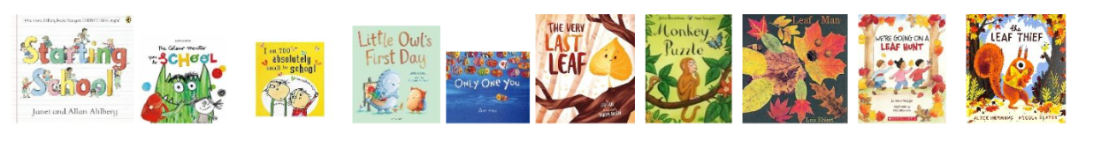
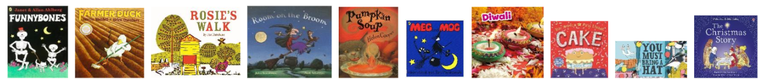
Spring
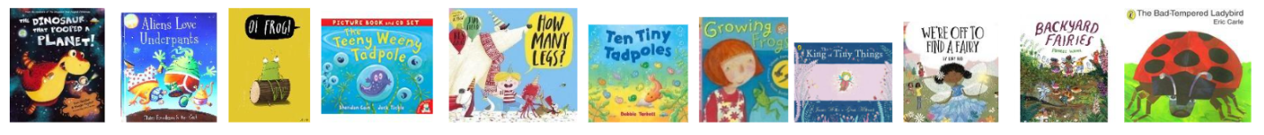
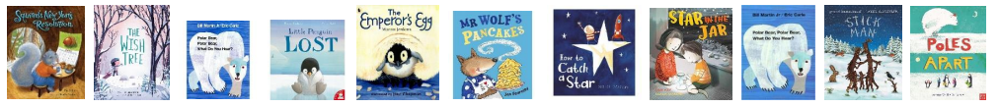
Summer
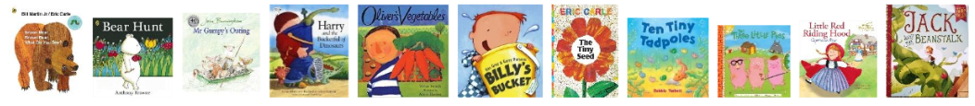
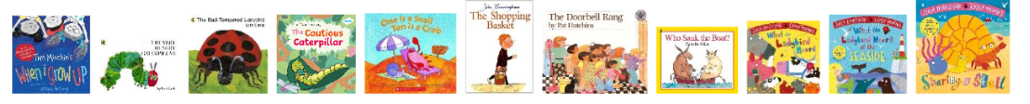

Prime Areas of Development - Prime areas of development and learning lay vital foundations in the early years.
The Prime Areas of Learning are: Communication and language, Physical development and Personal, social and emotional development.
Communication and Language
Understand how to listen carefully and why listening is important.  Engage in story times, rhymes, and songs.  Maintain attention in whole class/groups.  Follow 1 step instructions.  Understand ‘Who, what, how? questions.  Use sentences 4-6 words.  Use talk to organise play. |  | Listen in familiar & new situations.  Engage in story times.  Maintain attention in new situations.  Ask questions to find out more and to check they understand what has been said to them.  Follow instructions with 2 parts in a familiar situation.  Start a conversation with peers and familiar adults and continue for many turns.  Develop social phrases |  | Listen attentively in a range of situations.  Maintain attention during appropriate activity.  Engage in non-fiction books.  Consider the listener and take turns.  Use talk to organise/stand for something else in play.  Begin to use past tense.  Begin to recount past events. |  | Understand why listening is important.  Maintain attention in different contexts.  Use talk to help work out problems and organise thinking and activities to explain how things work and why they might happen.  Ask questions to find out more and check understanding.  Articulate their ideas and thoughts in well-formed sentences.  Listen to and talk about selected non-fiction to develop a deep familiarity with new knowledge and vocabulary.  Begin to connect one idea or action to another using a range of connectives.  Describe events in some detail. |  | Listen and understand instructions while busy with another task.  Maintain activity while listening.  Understand how, why, where questions.  Describe events in some detail.  Express ideas about feelings and experiences.  Articulate their ideas and thoughts in well-formed sentences.  Use language to reason. |  | Listen and respond with relevant questions, comments, or actions.  Attend to others in play.  Make comments and clarify thinking with questions.  Retell the story once they have developed a deep familiarity with the text; some as exact repetition and some in their own words.  Speak in well-formed sentences with some detail.  Use new vocabulary in different contexts.  Use past, present, and future tenses in conversation with peers and adults. Use conjunctions to extend and articulate their ideas.
Personal, Social, Emotional Development - Children’s personal, social and emotional development (PSED) is crucial for children to lead healthy and happy lives, and is fundamental to their cognitive development. Underpinning their personal development are the important attachments that shape their social world. Strong, warm and supportive relationships with adults enable children to learn how to understand their own feelings and those of others.
New beginnings: starting school, following rules, communicating and receiving kindness, making and keeping good friends.  Can talk about feelings.  Welcome distractions when upset.  Increasingly follow rules.  Know likes and dislikes.  Independently organise belongings in the morning.  Manage personal hygiene.  Build constructive and respectful relationships. |  | Beginning to express their feelings and consider the perspectives of others.  Begin to take turns and share resources.  Independently choose where they would like to play.  Continue to build constructive and respectful relationships. |  | Show pride in achievements.  Understand behavioural expectations of the setting.  Can explain right from wrong and try to behave accordingly.  Manage their own needs.  Can identify kindness.  Seek others to share activities and experiences. |  | Can make choices and communicate what they need.  Begin to show persistence when faced with challenges.  Can keep play going by co-operating, listening, speaking, and explaining.  Can reflect on the work of others and self-evaluate their own work. |  | Beginning to know that children think and respond in different ways to them.  Can talk about their own abilities positively.  Confident to try new activities  Show resilience and perseverance. |  | Able to identify and moderate own feelings.  See themselves as a unique and valued individual.  Can seek out a challenge and enjoy the process.  Show sensitivity to others’ needs and feelings.
Religious Education Key Question F1:  Where do we belong? |  | Religious Education Key Question F2:  Which times are special and why? |  | Religious Education Key question F3: What is special about our world? |  | Religious Education Key Question F5: Which people are special and why? |  | Religious Education Key question F4: Which places are special and why? |  | Religious Education Key Question F6: Which stories are special and why?
Christianity, Islam & Judaism |  | Christianity, Hinduism & Judaism |  | Christianity, Islam & Judaism |  | Christianity, Islam & Judaism |  | Christianity and Islam |  | Christianity, Hinduism and Islam
Respect:  Themselves, special things in their own lives.  Talk about and describe features of their own family, talk about families in other countries across the world |  | Respect:  Recognise that people have different beliefs and celebrate special times in different ways.  Recognise some similarities and differences between life in this country and life in other countries.  Look closely at and make comparisons between this country and the lives of people in other countries within the world (homes around the world) |  | Respect:  Understand the value of being curious and interested in finding out about people within their own community and in other countries - special places and events or objects – through non-fiction texts, stories, visitors, celebrations. |  | Respect:  Understand the value of being curious and interested in finding out about people within their own community and in other countries - special places and events or objects – through non-fiction texts, stories, visitors, celebrations. |  | Respect:  Understand that some places are special to members of their community. |  | Respect:  Animals and know how to care for animals
Physical Development - Physical activity is vital in children’s all-round development, enabling them to pursue happy, healthy and active lives. By creating games and providing opportunities for play both indoors and outdoors, adults can support children to develop their core strength, stability, balance, spatial awareness, co-ordination and agility. Gross motor skills provide the foundation for developing healthy bodies and social and emotional well-being. Fine motor control and precision helps with hand-eye co-ordination which is later linked to early literacy. Repeated and varied opportunities to explore and play with small world activities, puzzles, arts and crafts and the practice of using small tools, with feedback and support from adults, allow children to develop proficiency, control and confidence.
INTRODUCTION TO PE: UNIT 1 & 2 |  | FUNDAMENTALS: UNIT 1 & 2 |  | DANCE UNIT 1 & 2, GYMNASTICS UNIT 1 & 2 |  |  |  | GAMES UNIT 1 & 2, BALL SKILLS UNIT 1 & 2
Revise and refine the fundamental movement skills they have already acquired:  - Rolling  - Crawling  - Walking  - Jumping  - Running  - Hopping  - Skipping  - Climbing  Develop their small motor skills so that they can use a range of tools competently, safely and confidently (including pencils, paintbrushes, scissors, knives, forks, and spoons).  Navigate the new school environment (indoor & outdoor) safely, with care and control: make maps & go on hunts, spot obstacles, move safely, line up.  Know how to ‘reset’ areas within provision and how to tidy up at the end of a session to ensure the environment is safe, purposeful and organised.  Look after ourselves when organising our belongings coming into school/going home, eating and going to the toilet.  Learn to put on our coat or cardigan/jumper independently.  Make healthy choices at lunchtime - try new foods when staying for lunch in school, attempt to use cutlery safely and clear tray when finished.  Begin to develop gross & small motor skills though ‘Squiggle while you wiggle’ sessions zig-zag, spiral, wavy, square, dotty.  Develop fine motor skills using tongs & tweezers to pick up and move small objects Introduce scissor skills with support: holding scissors (appropriate for developmental stage) correctly to snip, then cut straight then wavy lines to a point. |  | Progress towards a more fluent style of moving, with developing control and grace.  Use their core muscle strength to achieve a good posture when sitting at a table or sitting on the floor.  Confidently and safely use a range of large and small apparatus indoors and outside, alone and in a group.  Develop overall body- strength, balance, co-ordination and agility.  Further develop the skills they need to manage the school day successfully:  - lining up and queuing  - mealtimes  - personal hygiene  Understand the difference between a ‘hazard’ and a ‘risk’ indoors and outdoors. Move around the school environment showing care and consideration for their own safety and that of others: lining up, queuing up, waiting, playing alone or in a group.  Look after ourselves: develop self-care skills: put on outdoor wetsuit and wellies, attempt to fasten coat, open snack independently, dress up in role play costumes.  Use cutlery at lunchtime independently to cut food and feed ourselves.  Handle equipment and tools effectively, including introducing pincer grip (‘crocodile snap’) when holding pencils for writing.  Practise the correct letter formation of letters in name using RWI prompts.  Strengthen scissor skills and develop independence when cutting around regular shapes.  Use creative tools and equipment in playdough area and creative area. |  | Develop the overall body strength, coordination, balance and agility needed to engage successfully with future physical education disciplines.  Combine different movements with ease and fluency.  Further develop and refine a range of ball skills including: throwing, catching, kicking, passing, batting and aiming.  Develop confidence, competence, precision and accuracy when engaging in activities that involve a ball.  Develop the foundations of a handwriting style which is fast, accurate and efficient.  Know and talk about the different factors that support their overall health and wellbeing:  - physical activity,  - healthy eating,  - toothbrushing,  - sensible amounts of ‘screen time’,  - sleep routine,  - being a safe pedestrian. |  |  |  | Further develop and refine a range of ball skills including: throwing, catching, kicking, passing, batting, and aiming. Develop confidence, competence, precision and accuracy when engaging in activities that involve a ball.  Combine different movements with ease and fluency  Confidently and safely use a range of large and small apparatus indoors and outside, alone and in a group. Develop overall body-strength, balance, coordination and agility.  Gross Motor Skills  - Negotiate space and obstacles safely, with consideration for themselves and others;  - Demonstrate strength, balance and coordination when playing;  - Move energetically, such as running, jumping, dancing, hopping, skipping and climbing.  Fine Motor Skills  - Hold a pencil effectively in preparation for fluent writing – using the tripod grip in almost all cases;  - Use a range of small tools, including scissors, paint brushes and cutlery;  - Begin to show accuracy and care when drawing
Specific Areas of Development - Specific areas of learning and development provide children with knowledge and skills to flourish in society.
The 4 Specific Areas of Learning are: Literacy, Maths, Understanding The World, Expressive Arts and Design.
Literacy and Phonics
Comprehension:  Listen and enjoy sharing a range of books.  Hold a book correctly, handle it with care.  Know that a book has a beginning and an end and can hold the book the right way up and turn some pages appropriately.  Know that text in English is read top to bottom and left to right.  Know the difference between text and illustrations.  Recognise some familiar words in print, e.g., own name or advertising logos.  Enjoy joining in with rhyme, songs and poems.  Explain in simple terms what is happening in a picture in a familiar story.  Complete a repeated refrain in a familiar rhyme, story or poem being read aloud. |  | Comprehension:  Experience and respond to different types of books, e.g., story books, factual/real-world books, rhyming and non-rhyming stories, realistic and fantasy stories.  Respond to ‘who’, ‘where’ ‘what’ and ‘when’ questions linked to text and illustrations.  Make simple inferences to answer yes/no questions about characters' emotions in a familiar picture book read aloud to them, with prompts.  Sequence two events from a familiar story, using puppets, pictures from a book or role-play. |  | Comprehension:  Use picture clues to help read a simple text.  Make a simple prediction based on the pictures or text of a straightforward story that is read aloud to them.  Show understanding of some words and phrases in a story that is read aloud to them.  Express a preference for a book, song or rhyme, from a limited selection.  Play is influenced by the experience of books (small world, role play). |  | Comprehension:  Retell stories in the correct sequence, draw on language patterns of stories.  With prompting, show understanding of many common words and phrases in a story that is read aloud to them.  Suggest how an unfamiliar story read aloud to them might end.  Give a simple opinion on a book they have read, when prompted.  Recognise repetition of words or phrases in a short passage of text.  Play influenced by experience of books  Innovate a well-known story with support. |  | Comprehension:  Correctly sequence a story or event using pictures and/or captions.  Make simple, plausible suggestions about what will happen next in a book they are reading.  Know the difference between different types of texts (fiction, nonfiction, poetry)  Make inferences to answer a question beginning 'Why do you think…?' in a picture book that has been read to them, where the answer is clearly signposted.  Play influenced by experience of books - gestures and actions used to act out a story, event or rhyme from text or illustrations. |  | Comprehension:  Play influenced by experience of books - act out stories through role play activities, using simple props (e.g. hats, masks, clothes, etc.) and appropriate vocabulary. Innovate a known story.  Recall the main points in text in the correct sequence, using your own words and include new vocabulary.  When prompted, say whether they liked or disliked a book, and give a simple justification or make a relevant comment.  With prompting, sometimes show understanding of some less familiar words and phrases in a story that is read aloud to them.
Word Reading:  Hear general sound discrimination and be able to orally blend and segment |  | Word Reading:  Read individual letters by saying the sounds for them.  Orally blend sounds into words, so that they can read short words made up of known letter-sound correspondences. |  | Word Reading:  Read individual letters by saying the sounds for them.  Blend sounds into words, so that they can read short words made up of known letter-sound correspondences.  Read a few common exception words (red words) matched to the RWI phonic programme. |  | Word Reading:  Read some letter groups that each represent one sound and say sounds for them.  Read simple phrases and sentences made up of words with known letter–sound correspondences and, where necessary, a few exception words. |  | Word Reading:  Read some letter groups that each represent one sound and say sounds for them.  Read simple phrases and sentences made up of words with known letter–sound correspondences and, where necessary, a few exception words. |  | Word Reading:  Read some ‘red’ words from across set 2 sounds and Red/Green storybooks e.g. said, like, have, so.  Re-read what they have written to check that it makes sense.
Re-read books to build up their confidence in word reading, their fluency and their understanding and enjoyment. Read books consistent with their phonic knowledge.
Phonics:  Children are taught their Set 1 sounds:  m, a, s, d, t, i, n, p, g, o, c, k, u, b, f, e, l, sh, h, r, j, v, w, x, y, z, th, ch, qu, ng, nk |  | Phonics:  Recap on set 1 special friends: th, ch, qu, ng, nk  Children are taught to blend sounds into words orally.  Children are taught to blend single-letter sounds (word time 1.1-1.4) |  | Phonics:  Recap on set 1 special friends: th, ch, qu, ng, nk  Secure blending of words with special friends  (word time 1.5 and 1.6). |  | Phonics:  Recap on any set 1 sounds (addressing sound gaps).  Secure blending on words containing all set 1 sounds.  Children are taught to blend words containing 4/5 sounds and consonant blends (word time 1.6 and 1.7).  To be exposed to some common exception words: put, the, I, no, of, my, for, he |  | Phonics:  Children are taught their set 2 sounds: ay, ee, igh, ow, oo, oo, ar, or, air, ir, ou, oy  To recall previous common exception words and be exposed to new common exception words: your, said, you, be, are |  | Phonics:  Children are taught their set 2 sounds: ay, ee, igh, ow, oo, oo, ar, or, air, ir, ou, oy  Children are taught to blend words containing set 2 sounds  Children build speed of reading words containing set 1 sounds.
Emergent writing:  Develop listening and speaking skills in a range of contexts. Aware that writing communicates meaning. Give meaning to marks they make. Understand that thoughts can be written down. Write their name copying it from a name card or try to write it from memory.  Composition:  Use talk to organise describe events and experiences.  Spelling:  Orally segment sounds in simple words.  Write their name by copying it from a name card or try to write it from memory.  Handwriting:  Know that print carries meaning and in English, is read from left to right and top to bottom.  Draws lines and circles. |  | Emergent writing:  Copies adult writing behaviour e.g. writing on a whiteboard, writing messages. Makes make marks and drawings using increasing control. Know there is a sound/symbol relationship. Use some recognisable letters and own symbols. Write letters and strings, sometimes in clusters like words.  Composition:  Use talk to link ideas, clarify thinking and feelings. Understands that thoughts and stories can be written down.  Spelling: Orally spell VC and CVC words by identifying the sounds.  Write own name.  Handwriting: Form letters from their name correctly. Recognise that after a word there is a space. |  | Emergent writing:  Use appropriate letters for initial sounds.  Composition: Orally compose a sentence and hold it in memory before attempting to write it.  Spelling: Spell to write VC and CVC words independently using Phase 2 graphemes.  Handwriting: Shows a dominant hand. Write from left to right and top to bottom. Begin to form recognisable letters. |  | Emergent writing:  Build words using letter sounds in writing.  Composition:  Orally compose a sentence and hold it in memory before attempting to write it and use simple conjunctions.  Spelling:  Spell to write VC, CVC and CVCC words independently using set 1 and 2 speed sounds.  Spell some irregular common (red) words e.g. the, to, no, go independently.  Handwriting:  Holds a pencil effectively to form recognisable letters. Know how to form clear ascenders and descenders. |  | Emergent writing:  Continue to build on knowledge of letter sounds to build words in writing. Use writing in play. Use familiar words in their writing.  Composition:  Write a simple sentence with a full stop.  Spelling:  Spell words by drawing on knowledge of known grapheme correspondences.  Make phonetically plausible attempts when writing more complex unknown words.  Handwriting:  Form most lower-case letters correctly, starting and finishing in the right place, going the right way round and correctly orientated. Include spaces between words. |  | Emergent writing:  Show awareness of the different audiences for writing.  Write short sentences with words with known letter-sound correspondences using a capital letter, finger spaces and a full stop.  Composition:  Write a simple narrative in short sentences with known letter-sound correspondences using a capital letter and full stop.  Write different text forms for different purposes (e.g. lists, stories, instructions.  Begin to discuss features of their own writing e.g. what kind of story have they written.  Spelling:  Spell words by drawing on knowledge of known grapheme correspondences.  Make phonetically plausible attempts when writing more complex unknown words e.g. using set 2 sounds CCVCC  Spell irregular common (red) words e.g., he, she, we, be, me independently.  Handwriting: Use a pencil confidently to write letters that can be clearly recognised and form some capital letters correctly.
Mathematics - Developing a strong grounding in number is essential so that all children develop the necessary building blocks to excel mathematically. Children should be able to count confidently, develop a deep understanding of the numbers to 10, the relationships between them and the patterns within those numbers.
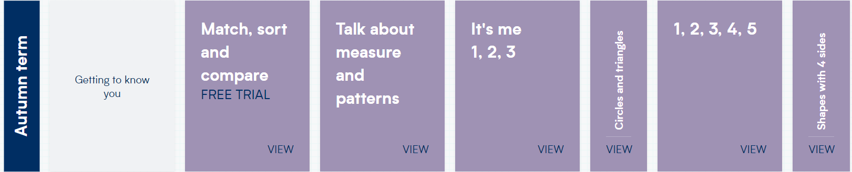 |  |  |  | 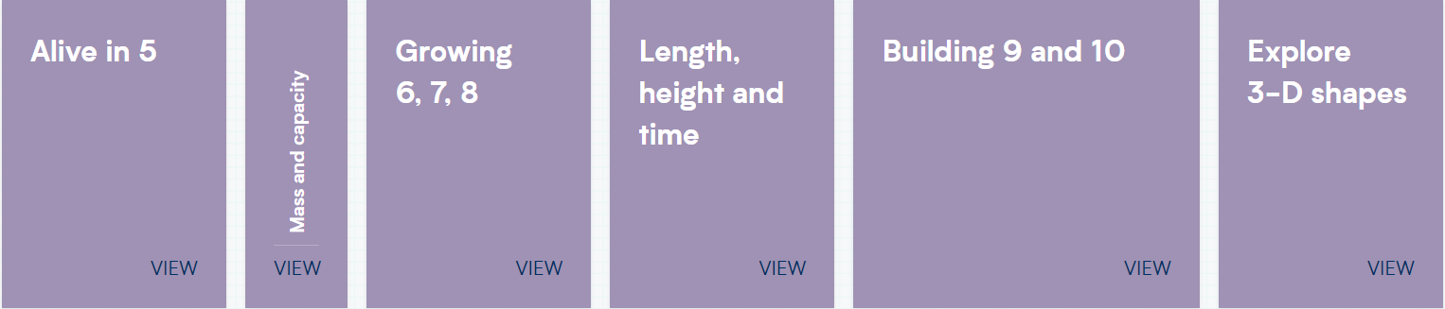 |  |  |  | 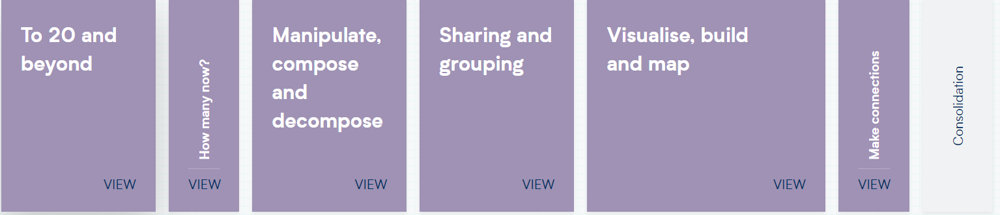
Count objects, actions, and sounds.  Subitise  Matching. Sorting & Comparing  Comparing amounts  Comparing size, mass & capacity Exploring pattern - making simple.  Subitising |  |  |  |  |  | Explore the composition of numbers to 10  Subitise  Automatic recall number bonds 0-10  Numbers 7, 8, 9  Making pairs.  Combining groups  Number bonds  3D shapes  Pattern. |  | Explore the composition of numbers beyond 10.  Subitise  Automatic recall number bonds 0-10  Number 10 and beyond– subitising, counting, sorting, matching, comparing, ordering  Composition of numbers to 10 and beyond  Counting patterns to 10 and beyond  Spatial reasoning.  3D shape  Match, rotate, and manipulate  Pattern – AABB, BBA  Sunflower Challenge
  Explore the composition of numbers to 10
  Subitise
  Automatic recall number bonds 0-10
  Representing 1,2,3  Comparing 1,2,3  Composition of 1,2,3  Formation of 1,2,3  Circles and triangles  Positional language | Representing 4,5  Comparing 4,5  Composition of 4,5  Formation of 4,5  One more and less  Shapes with 4 sides  Time
  Explore the composition of numbers to 10
  Subitise
  Automatic recall number bonds 0-10
  Introducing zero  Comparing numbers to 5  Composition of 5  Comparing Mass  Comparing Capacity | Number 6, 7, 8  Making pairs  Doubles  Combining 2  groups  Length, height  Time
  Explore the composition of numbers beyond 10.
  Subitise
  Automatic recall number bonds 0-10
  Adding more  Taking away  Number bonds  Shape – spatial reasoning | Doubling  Sharing and  grouping  Even and odd  Patterns and  relationships
Link the number symbol with its cardinal number value. Select, rotate, and manipulate shapes to develop spatial reasoning skills.
Count beyond ten. Compare numbers Compose and decompose shapes so that children recognise a shape can have other shapes within it, just as numbers can.
Understand the ‘one more/one less than’ relationship between consecutive numbers. Continue, copy, and create repeating patterns.
Compare length, weight, and capacity.
Understanding the World - Understanding the world involves guiding children to make sense of their physical world and their community. As well as building important knowledge, this extends their familiarity with words that support understanding across domains. Enriching and widening children’s vocabulary will support later reading comprehension. Begin to develop a sense of continuity and change by being able to compare and contrast characters from stories throughout the year, including figures from the past.
Communication: Comment on what they notice about the environment where they live and understand the effect of the changing seasons on the natural world around them. Describe what they see, hear, and feel outside.
Observation:
Explore the natural world around them by taking part in weekly forest school inspired ‘Nature School’ sessions and making observations and drawing pictures of animals and plants. Understand the need to respect and care for the natural environment and all living things.
History

History Skills:  Changes within living memory  Chronology: Our Personal History  Talk about and understand changes in their own lifetime, by creating a personal timeline.  Children can talk about who is in their family.  Children can talk about what they do as a family.  Children know that there are lots of different types of families.  Children know that it is ok to believe something different from other people.  Children know that people celebrate festivals.  Children can discuss simple changes that have happened to them since they were a baby. |  | History Skills:  Significant historical events, people and places in their own locality  Chronology: An understanding of the Past and Present  Use the language of time when talking about past/present events in their own lives and in the lives of others including people they have learnt about through books.  Our local area in photographs - local Wavertree.  Historical Figure:  Kitty Wilkinson  Talk about key roles people have in society both in the present and past. Name and describe people who are familiar to them within their community e.g., police, fire service, doctors, dentist.  How has this changed? |  | History Skills:  The lives of significant individuals in the past  Chronology: Find out about key historical events and compare them e.g Modern Space Race.  Historical Figure:  Neil Armstrong  Tim Peake |  | History Skills:  The lives of significant individuals in the past  Historical Figure:  Florence Nightingale  Who was she? How can we compare her with the people who help us in the present day? |  | History Skills:  Events beyond living memory  Chronology: Recount an event, orally, pictorial and/or with captions.  Historical Event:  What happened during the sinking of the Titanic? Why is it a historically significant event? |  | History Skills:  Order experiences in relation to themselves and others, including stories.  Chronology: Recount an event, orally, pictorial and/or with captions.Describe features of objects, people, places at different times and make comparisons. Talk about what is the same and different
Geography
Mapping: Talk about the features of their immediate environment with visual representations e.g., classroom maps, Pete’s story map around school, seating maps, nature area map and read commons signs and logos.  Our Local Area/Weather  Classroom and school environment  The name of the local area and city: Liverpool/Wavertree  Maps and symbols, aerial maps, birds-eye view.  Seasons and weather: Autumn/Winter |  | Mapping: Use technology e.g., a BeeBot and begin to show spatial awareness. Use positional language i.e., under, beside, on top of etc.  Our Local Area/Weather  Classroom and school environment  The name of the local area and city: Liverpool/Wavertree  Maps and symbols, aerial maps, birds-eye view.  Seasons and weather: Autumn/Winter |  | Mapping: Program a BeeBot or instruct a friend to move along a track or small world setup in a specific direction using terms up, down, side.  Identify on a map - Recognise some environments that are different to the one in which they live e.g. Antarctica.  Enquiry: Use technology and IT equipment to make observations or find information about different locations and places. Recognise, know, and describe features of different places. Look closely at similarities and differences.  Our World/Weather  Contrasting environment (habitats).  Similarities and differences between places e.g. countryside and town, and polar lands/Liverpool.  Seasons and weather:  Spring |  | Mapping: Complete a simple BeeBot program using a grid map or carpet squares.  Enquiry - comment and ask questions about their immediate environment, other places which are familiar to them, and places they have learnt about e.g., school nature area and the town centre.  Our World/Weather  Contrasting environment (habitats).  Similarities and differences between places e.g. countryside and town, and polar lands/Liverpool.  Seasons and weather:  Spring |  | Mapping: Draw information from a simple map and identify landmarks of our local area walk.  Enquiry: Comment and ask questions about the different parts of the local community. E.g., weather, hill, house, farm, church, shop. Use photos and pictures to locate places and place on a simple map.  Find out about their local area by talking to people, examining photographs, and visiting local places.  Maps and Mapping  Draw, make and build simple maps using a variety of construction resources.  Use simple map symbols  Natural and manmade things in the world  Seasons and weather: Summer |  | Mapping: Create own maps using grid paper and symbols (x marks the spot treasure maps)  Enquiry: Recognise, know, and describe features of different places. Look closely at similarities and differences between their immediate environment and different places they have visited, learnt about through books or websites  Maps and Mapping  Draw, make and build simple maps using a variety of construction resources.  Use simple map symbols  Natural and manmade things in the world  Seasons and weather: Summer
Science

Explore the natural world around them.  Describe what they see, hear and feel whilst outside. |  | Recognise some environments that are different from the one in which they live.  Ice melting experiment |  | Understand the effect of changing seasons on the natural world around them.  Global warming effects |  | Life cycles and growing plants.  Butterfly lifecycle. |  |  |  | How we have changed since birth.  Human life-cycles.  (Birth, child, toddler, adult, teenager, geriatric).
Expressive Arts and Design - Explore, use, and refine a variety of artistic effects to express their ideas and feelings. Explore and engage in music making and dance, performing solo or in groups. Singing – well known nursery rhymes, familiar songs and chants
Artist in Focus: Kandinsky  Artistic Skill: Concentric circles and primary/secondary colours. Observational skills.  Outcome: Portrait, dot day, concentric circles. |  | Artist in Focus: Andy Goldsworthy  Artistic Skill: Sculpting and junk modelling.  Outcome: Autumn journey sculpture/journey stick. |  | Artist in Focus: Vincent Van Gogh  Artistic Skill: Demonstrating different brush strokes.  Outcome: Colour mixing, finger painting and different brush strokes for effect. |  | Artist in Focus: Jackson Pollock  Artistic Skill: Involves splashing, using gestural brushstrokes and dripping paint onto canvas rather than carefully applying it - 'action painting'.  Outcome: Using splat painting to create an underwater habitat. |  | Artist in Focus: Georgia O'Keefe  Artistic Skill:  Using a variety of media—pastel, charcoal, watercolour.  Outcome: Using various artistic tools to create enlarged paintings of flowers.
Musical learning focus: Listening and responding to different styles of music.  Embedding foundations of the interrelated dimensions of music.  Learning to sing or sing along with nursery rhymes and action songs.  Improvising leading to playing classroom instruments.  Share and perform the learning that has taken place.  Music theme: ME!  Music Charanga Songs:  Pat-a-cake  1, 2, 3, 4, 5, Once I Caught a Fish Alive  This Old Man  Five Little Ducks  Name Song  Things for Fingers |  | - Musical learning focus: Listening and responding to different styles of music  - Embedding foundations of the interrelated dimensions of music  - Learning to sing or sing along with nursery rhymes and action songs  - Improvising leading to playing classroom instruments  - Share and perform the learning that has taken place  Music Theme: My Stories  Music Charanga Songs:  I’m A Little Teapot  The Grand Old Duke of York  Ring O’ Roses  Hickory Dickory Dock  Not Too Difficult  The ABC Song |  | - Musical learning focus: Listening and responding to different styles of music  - Embedding foundations of the interrelated dimensions of music  - Learning to sing or sing along with nursery rhymes and action songs  - Improvising leading to playing classroom instruments  - Singing and learning to play instruments within a song  - Share and perform the learning that has taken place  Learn to sing nursery rhymes and action songs:  - Old Macdonald  - Incy Wincy Spider  - Baa Baa Black Sheep  - Row, Row, Row Your Boat  - The Wheels On The Bus  - The Hokey Cokey  Music Theme: Everyone  Music Charanga Songs:  - Wind The Bobbin Up  Rock-a-bye Baby  Five Little Monkeys Jumping On The Bed  Twinkle Twinkle  If You're Happy And You Know It  Head, Shoulders, Knees and Toes |  | - Musical learning focus: Listening and responding to different styles of music  - Embedding foundations of the interrelated dimensions of music  - Learning to sing or sing along with nursery rhymes and action songs  - Improvising leading to playing classroom instruments  - Singing and learning to play instruments within a song  - Share and perform the learning that has taken place  Music Theme: Our World  Music Charanga Songs:  - Old Macdonald  Incy Wincy Spider  Baa Baa Black Sheep  Row, Row, Row Your Boat  The Wheels On The Bus  The Hokey Cokey |  | - Musical learning focus: Listening and appraising Funk music  - Embedding foundations of the interrelated dimensions of music using voices and instruments  - Learning to sing Big Bear Funk and revisiting other nursery rhymes and action songs  - Playing instruments within the song  - Improvisation using voices and instruments  - Riff-based composition  - Share and perform the learning that has taken place  Music Theme: Consolidation  Music Charanga Songs:  Big Bear Funk is a transition Unit that prepares children for their musical learning in Year 1.
Mini Mash  General Computing Skills |  | Mini Mash  2Paint |  | Mini Mash  Simple City |  | Mini Mash  Fairytale Slideshows |  | Mini Mash  Phonics

