Mosspits Lane Primary School
Personal, Social, Health & Economic Education Policy



Approved by: | A. Dunning  K. Owens | Date: October 2020
Last reviewed on: | May 2022
Next review due by: | May 2023

Policy Context and Rationale
This policy covers our school approach to PSHE education (hereby known as PSHE) and has been written by the subject lead and in consultation with the curriculum lead and senior management team. Consultation has taken the form of pupil voice, staff voice and developed with curriculum leaders. As consultation and involvement of pupils in PSHE is crucial to meet their needs and address the issues they are facing, the pupils have been at the centre of our approach. Key needs have been identified by our pupils and underpinned by the Education Act 2011. We have further developed our approach by looking at local data. The need for promoting emotional well-being and physical development of all children is evident as a pressing issue in our school. PSHE recognises a role in supporting children’s wider development and preparing all students for any opportunity, responsibility and experiences in later life. The 2006 Education and Inspections Act has placed a duty on Governing Bodies ‘to promote the wellbeing of pupils at the school’ and this is echoed in our bespoke planning and curriculum.
Policy Availability
Parents and carers will be informed about the policy through our school website, where they can access the PSHE statement and curriculum map information. They will be presented with regular updates regarding the curriculum and what is taught when. Parents will be provided with the most up to date legislation and evidence for the PSHE programme of study and this will be available to access on the school website. Parents and carers will have the opportunity to discuss the policy in place with the subject lead and curriculum lead, through online surveys and organised meetings if any concerns are raised. This will enable a shared ethos within the school community.
Policy Aims and Objectives
Our school’s ethos and overarching aims and objectives for our pupils are:
- Help pupils develop feelings of self-respect, confidence and empathy.
- Provide a framework in which sensitive discussions can take place.
- Develop knowledge and understanding in main core areas – families and those who care for me, caring friendships, respectful relationships, online relationships, mental health, internet safety and harms, physical health and fitness, healthy eating, drugs, alcohol and tobacco, health and prevention, basic first aid and changing adolescent body.
- To develop the whole child through a cross-curricular approach through English, Science, P.E and Computing.
Our PSHE programme promotes the school values of: nurturing through respect, inspiring through creativity and succeeding beyond expectations.
Creating a Safe and Supportive Learning Environment
Because PSHE works within pupils’ real life experiences, it is essential to establish a safe learning environment. Clear ‘ground rules’ and a confidentiality policy that is understood by all (adults and children) are important elements of creating this. In the course of PSHE lessons, pupils may indicate in some way that they are vulnerable or ‘at risk’. It is important to make a clear link to the school’s safeguarding/ child protection policy to ensure clarity about what is required in such circumstances. We will create a safe and supportive learning environment by ensuring vital distancing techniques are in place in lessons, ground rules are set, including keeping the conversation in the room, being respectful of others (disagreeing respectfully) and making no assumptions.
We will ensure that where pupils indicate that they may be vulnerable and at risk, they will get appropriate support by adapting lessons and the curriculum, involving outside agencies if necessary and having a strong relationship with the whole school community including parents and carers.
Entitlement and Equality of Opportunity
Classroom practice and pedagogy should take into account pupils’ ability, age, readiness and cultural backgrounds, and should be adjusted to enable all pupils to access the learning. Full PSHE provision should be accessible to every pupil, although parents have a right to withdraw their children from those parts of PSHE (RSE) not within the National Curriculum Science programmes of study. We promote the needs and interests of all pupils, irrespective of gender, culture, ability or personal circumstance by promoting diversity and inclusion. We expect all children to consider the needs of others and we provide a curriculum and provision that can be fully accessed by all pupils.
As far as is appropriate, pupils with special educational needs should follow the same PSHE programme as all other students. Careful consideration should be given concerning the level of differentiation needed, and in some cases the content or delivery will have to be adapted. Teachers and/or learning support assistants should work with individual pupils where required, and if appropriate. No child should be withdrawn from PSHE to catch up on other national curriculum subjects: these aspects of personal and social development are as important to all pupils as their academic achievement.
Intended Outcomes
As a result of our PSHE programme of learning, pupils will:
• know and understand key concepts of the PSHE and core themes.
• be able to clarify their values and beliefs and develop enquiry and interpersonal skills.
• develop the skills of responding respectfully, listening intently and seeking support when needed.
• understand they have a right to seek advice and support from others.
• understand they are entitled to a comprehensive, balanced and relevant body of factual information to inform their present and future choices
Learning and Teaching
PSHE needs to consider pupils’ starting points. Pupils will bring differing levels of knowledge and understanding to any issue explored. Often this prior learning is more complex than we might assume. Where possible, any new topic in PSHE should start by determining pupils’ prior knowledge through pre unit assessments and ‘check its’. The programme will be taught through a range of teaching methods and lessons will be recorded in many different ways depending on age and ability i.e. using big books, thoughts journals, annotations and video clips.
Research shows that attempts to scare or shock young people into making decisions rarely work, and can indeed ‘backfire’ by inadvertently creating excitement, curiosity or even status among pupils who accept the risk. This does not mean that potential consequences of the lifestyle choice should not be made clear, but balance is important. For example, young people frequently overestimate how often their peers take part in risky behaviours and feel that they are the ‘odd ones out’ if they don’t do the same. It is important that they are reassured that the majority of young people actually make positive, healthy lifestyle choices.
It is important that pupils are helped to make connections between the learning they receive in PSHE and their current and future ‘real life’ experiences. The skill of critical reflection is therefore at the heart of assessment for learning in our PSHE.
Planning
The planning provided to the children of Mosspits, is regularly reviewed and tailored to their ever-changing needs. Below is the curriculum map using resources from PSHE Association, NHS, 1 Decision and Growing up with Yasmine and Tom.
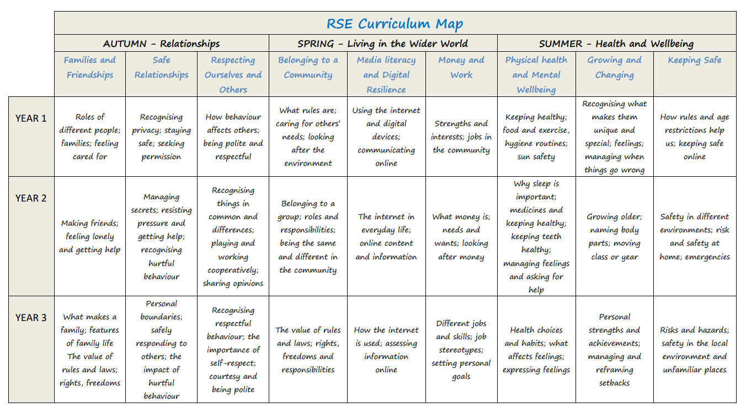
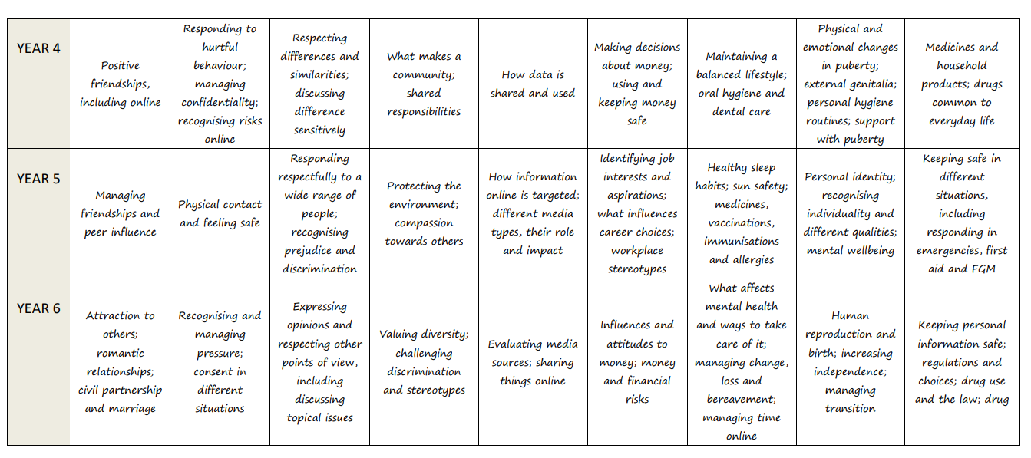
Timetabling
PSHE is most effectively taught through a ‘spiral programme’. This means organising learning into a series of recurring themes, often across a half term, on a yearly cycle. The level of demand increases across school years and learning is progressively deepened. This approach avoids PSHE becoming a string of ‘topics’ or disconnected ‘issues’. We allocate essential curriculum time to PSHE through weekly time needed sessions and extra time is built in when specific needs are identified i.e. Mental Health and Well-being Week and the ‘No Room for Racism’ Initiative. Planned enrichment days are used to develop and extend a school’s planned PSHE programme. Our PSHE provision is mapped and planned effectively to develop the whole child.
Assessment
PSHE alone is not responsible for pupils’ future lifestyle choices: as with any other subject, assessment in PSHE should focus on learning, set against the lesson objectives and outcomes. Children inform the learning process by identifying needs, collecting information to certify achievement and competence and informing others by reflecting on what they have learnt and putting this into action. Some aspects of PSHE lend themselves to formal assessments for example knowledge of facts. Whereas assessing the development of skills or the consideration of attitudes and values, may need a greater range of formal and informal strategies and more open-ended approaches. In order to address this, we assess pupils’ learning and progression through pre unit assessments, ‘check its’ and end of unit assessments. This is implemented from Early Years to Year Six and presented in a variety of different ways through confidence banners, mini-quizzes and mind maps.
It is also important to make sure you are assessing learning which is specific to PSHE and no other areas of the curriculum, such as English. It is important to recognise that assessment in PSHE is not about ‘passing or failing’, or about behavioural outcomes. Teachers and pupils both need to know what has been learned, and how learning and understanding has progressed.
Teaching Responsibility and Staff Training
The programme will be led by the PSHE Lead and supported by the Curriculum Lead and will be taught across the school, in all phases by teaching staff. It will be supported by teaching assistants who play a vital role in supporting pupils. Teachers responsible for teaching PSHE will receive training through bespoke CPD workshops led by the curriculum lead and subject lead and will be guided through by detailed and high quality planning and resources.
Visitors to the classroom will be encouraged to bring their expertise or personal stories to enrich pupil’s learning. However, the teacher should always manage this learning, ensuring that learning objectives and outcomes have been agreed with the visitor in advance, and that any input from visitors should be part of a planned, developmental programme rather than a substitute for it. Teachers should always be present to manage the learning, and to ensure that it is safe. In RSE, a school nurse can present and teach objectives but this should always be followed up by the class teacher to answer any queries or questions.
Confidentiality and Handling Disclosures
Due to the nature of PSHE, pupils’ learning may result in them seeking advice or support on a specific personal issue. Teachers cannot offer complete confidentiality; it is important for everyone’s safety that teachers and pupils are clear about what can and cannot be kept confidential. It is also very important for external contributors, including school nurses, to be clear about these rules and that whilst working in the classroom, they are bound by the school’s confidentiality policy, not their own. Ground rules are to be explained every lesson so that the children are aware of what is expected within the classroom.
Responding to Pupils Questions
It is important that pupils feel able to ask any questions that they wish and that their questions are valued. However, consideration should be given to how to respond to questions. If necessary, teachers also need to feel able to ask a pupil to wait for an answer to give them time to consult with the school’s leadership team if they feel this appropriate, or if the question raises potential safeguarding concerns. Teachers should feel able to work with colleagues if necessary to construct an appropriate answer. We will allow pupils to raise anonymous questions by using the class worry box and notes passed to the teacher at the end of each lesson. If a safeguarding issue is raised by an anonymous question, we will follow the safeguarding policy currently in place in school.
Links to Other School Policies and Areas of the Curriculum
This policy supports the following policies:
- Safeguarding Policy
- RSE Policy
- Online Safety and Acceptable Use
- Child Protection
- Anti-bullying
- Drug and Substance Misuse Education
- First Aid
- Grief, Bereavement and Separation
- Intimate Care
- Safeguarding Escalation
- Transition
- SEND
- Healthy Packed Lunch
Involving Parents and Carers
We are committed to working with parents and carers in all aspects of PSHE. All key documents are available through the school website including planning and resources. We will communicate with families and carers through online platforms including texting, emailing, Twitter, Dojo and the school website. If a parent wishes to withdraw their child, we will offer a meeting with the Head Teacher to explore all aspects of the curriculum and discuss options on how to deliver the important information discussed in these areas.
Review Date
The PSHE policy will be reviewed at least every 18 months-2 years to ensure that it continues to meet the needs of pupils, staff and parents, and that it is in line with current DfE advice and guidance, unless there’s urgent need to do so earlier. This policy will be reviewed in Summer 2022 and will be reviewed by the Curriculum Lead and Subject Lead.

