Activity | Attempt 1 | Attempt 2 | Attempt 3 | Attempt 4 | My Personal Best
Bouncing a ball on floor

Bouncing a ball on an object

Kick ups

Toe taps

Ball around body

Speed Bounce

How many can you perform in 30 seconds, have a 2 minutes rest between attempts.

PE - Home Learning activities

Activity list

Bouncing a ball on floor

Ball around body
Stair step ups

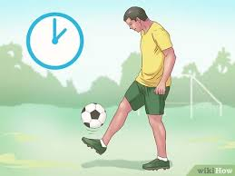
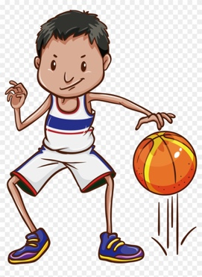
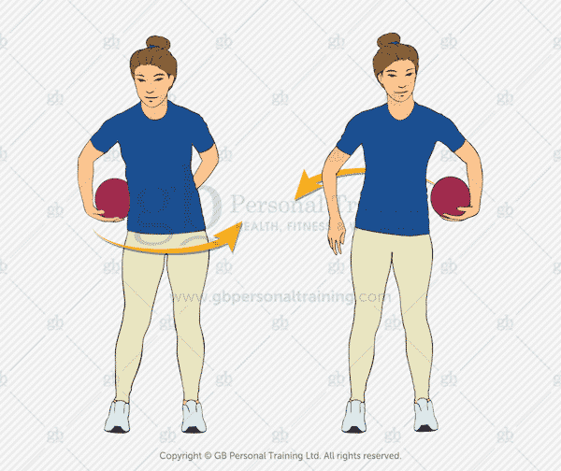

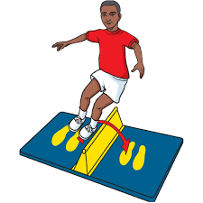
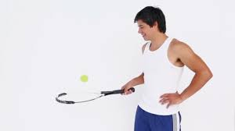
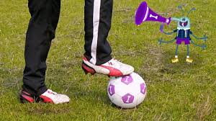
Speed bounce
Toe taps
Bouncing a ball on an object

