Activity | Attempt 1 | Attempt 2 | Attempt 3 | Attempt 4 | My Personal Best
Speed Bounce

Stair Steps

Star Jumps

Burpee

High Knees

Press Ups

How many can you perform in 30 seconds, have a 2 minutes rest between attempts.

PE - Home Learning activities

Activity list

Stair step ups
Burpee
Star jumps

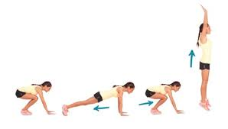
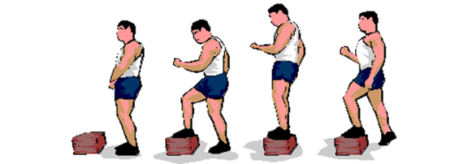
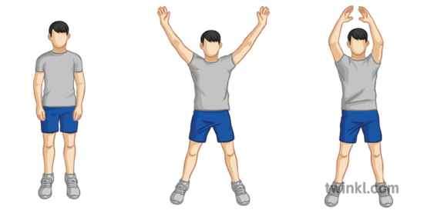

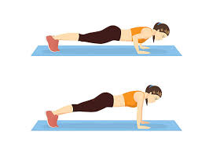
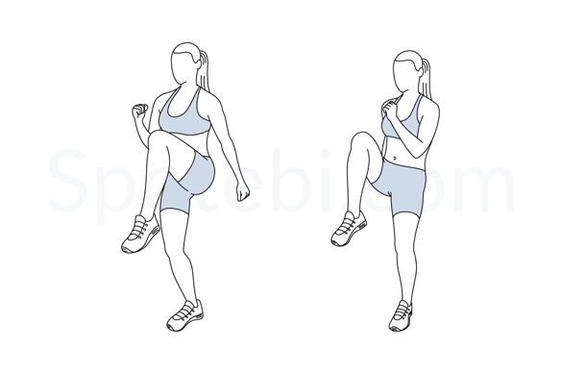
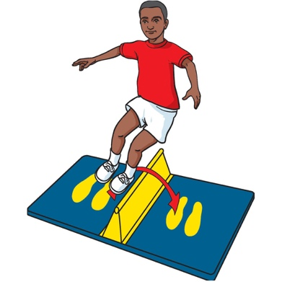
Press ups
High knees
Speed bounce

